Depending upon User Interface ,applications

CUI > Console Applications

GUI > Windows / Web applications

Windows / Web

Windows applications are standalone

Web Applications: applications which are available on web , we can access from anywhere

Through Internet

WWW

What do we need to access Web applications : Browser

Web Application

**Client Server**

Server > machine where our application is stored

Client > Browser , from where you access web application

IIS , Apache These are servers

Web Pages can be dynamic > By adding some script

On client side > javascript / jquery

On server side > Asp.Net

Before Asp.Net, we were using ASP

Why do we need protocols > They are rules that we need to follow while

Communicating

Why ?? Because we have minimum 2 layers , client and server

PROTOCOLS WILL BE THERE

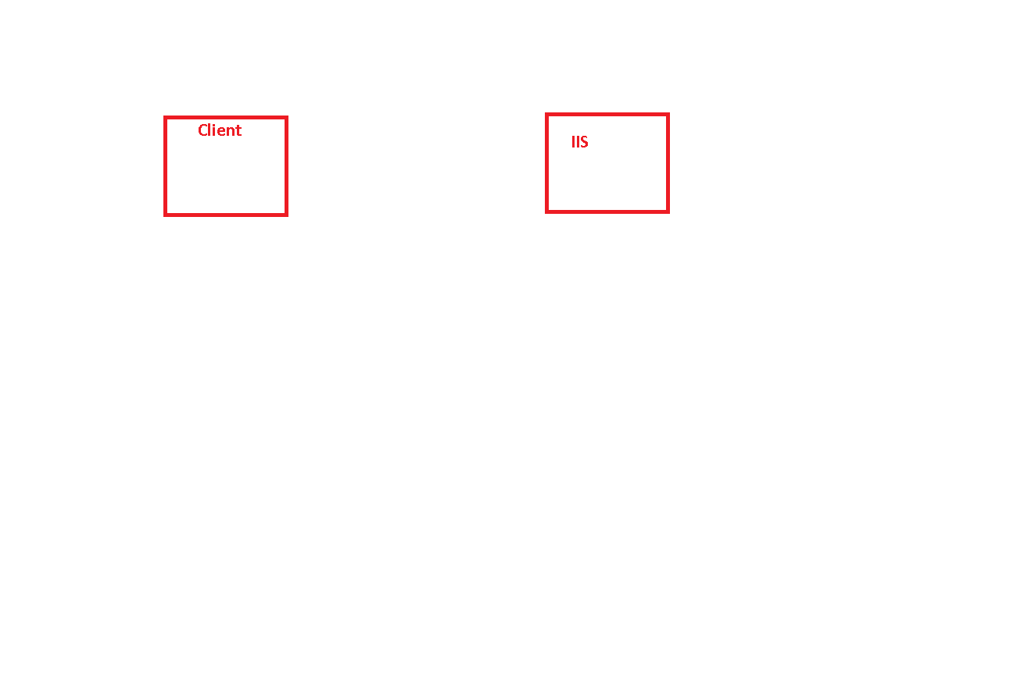

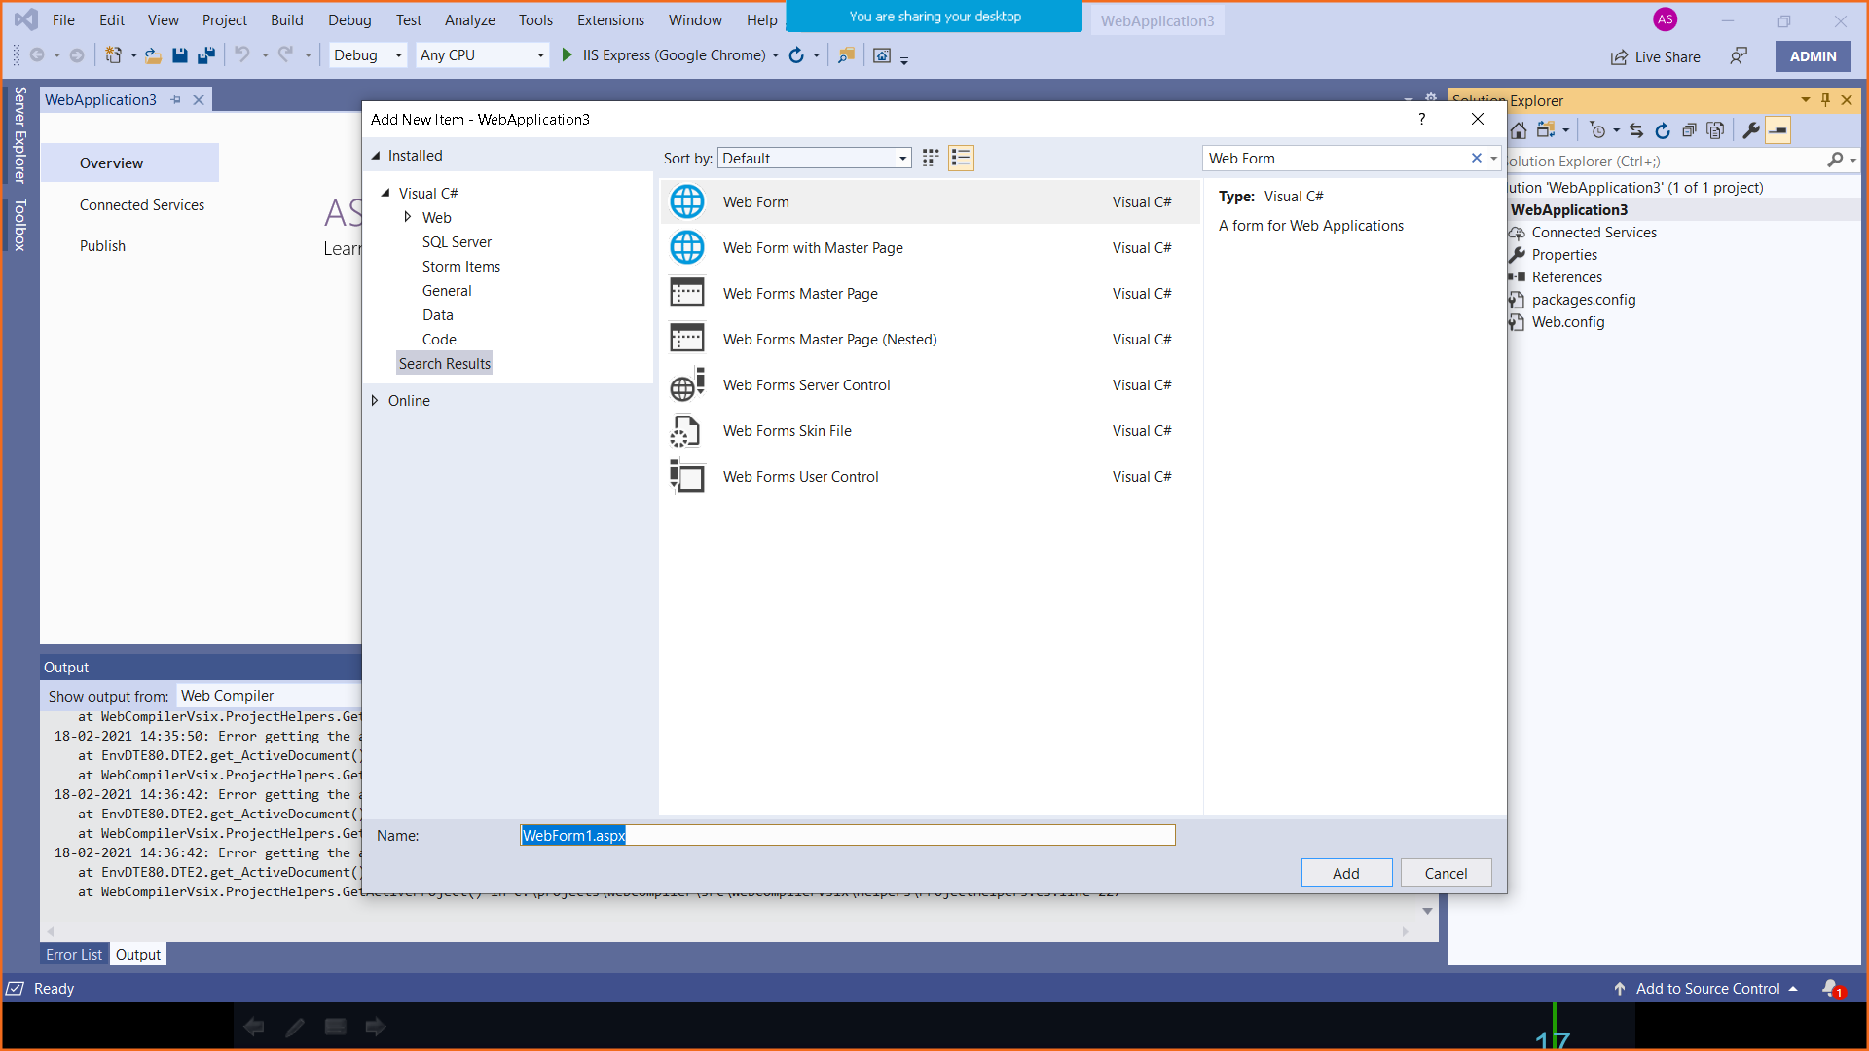

WebForm1.aspx

<%@ Page Language="C#" AutoEventWireup="true" CodeBehind="WebForm1.aspx.cs" Inherits="WebApplication3.WebForm1" %>

<!DOCTYPE html>

<html xmlns="http://www.w3.org/1999/xhtml">

<head runat="server">

<title></title>

</head>

<body>

<form id="form1" runat="server">

<div>

</div>

</form>

</body>

</html>

Page is directive

Web Applications are are of different types

Web Pages

Web Forms

WebForm1.aspx.cs

using System;

using System.Collections.Generic;

using System.Linq;

using System.Web;

using System.Web.UI;

using System.Web.UI.WebControls;

namespace WebApplication3

{

public partial class WebForm1 : System.Web.UI.Page

{

protected void Page_Load(object sender, EventArgs e)

{

}

}

}

Code Behind File

<%@ Page Language="C#" AutoEventWireup="true" CodeBehind="WebForm1.aspx.cs" Inherits="WebApplication3.WebForm1" %>

CodeBehind > Tells about the file which contains coding that will run on server

Inherits > Links with that class which contains all the methods

<asp:Label ID="lblNo1" runat="server" Text="Enter No 1"></asp:Label>

<asp:TextBox ID="txtNo1" runat="server"></asp:TextBox>

<br />

<asp:Label ID="lblNo2" runat="server" Text="Enter No 2"></asp:Label>

<asp:TextBox ID="txtNo2" runat="server"></asp:TextBox>

<br />

<asp:Label ID="lblResult" runat="server" Text="Result is"></asp:Label>

<asp:TextBox ID="txtResult" runat="server"></asp:TextBox>

<br />

<asp:Button ID="btnAdd" runat="server" Text="Add" OnClick="btnAdd_Click" />

.cs file

protected void btnAdd_Click(object sender, EventArgs e)

{

Response.Write("Hello");

txtResult.Text =( Convert.ToByte(txtNo1.Text) + Convert.ToByte(txtNo2.Text) ).ToString();

}